Blood Types and the Immune System
Graded out of 22 points
Table 1. Blood Types and the Antigens That Cause Them.
Blood Type | Red Blood Cell diagram | Recognized by:
 |  | Anti-A Antiserum? | Anti-B Antiserum?
A | 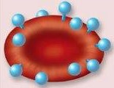 | Yes | No
B |  | No | Yes
AB | 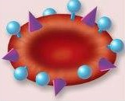 | Yes | Yes
O |  | No | No

Table 2. Compatibility of Blood Types.
Patient’s Blood Type | Patient’s Blood Contains Antigens | Can Receive Blood from Donors Who Are
A+ | A, Rh | A+, A-, O+, O-
A- | A only | A-, O-
B+ | B, Rh | B+, B-, O+, O-
B- | B only | B-, O-
AB+ | A, B, Rh | All types (universal receiver)
AB- | A, B | A-, B-, AB-, O-
O+ | Rh only | O+, O-
O- | None | O- only (universal donor)

Watch the following YouTube video for a demonstration of how this lab activity takes place.
https://www.youtube.com/watch?v=z1rRTnaWrMw

Table 3. Results of Blood Typing. (4 pts)
Sample # | Patient’s Name | Agglutinated by |  |  | Blood Type
 |  | A Antiserum? | B Antiserum? | Rh Antiserum?
1 | Mr. Jones
2 | Mr. Smith
3 | Mr. Green
4 | Ms. Brown

Use the photos below to fill in blanks of Table 3. The photo on the left shows the real data. Agglutination can be identified when text underneath is difficult to see. The image on the right shows the same data, but agglutination can be identified by a dark cloudy presence in the well.
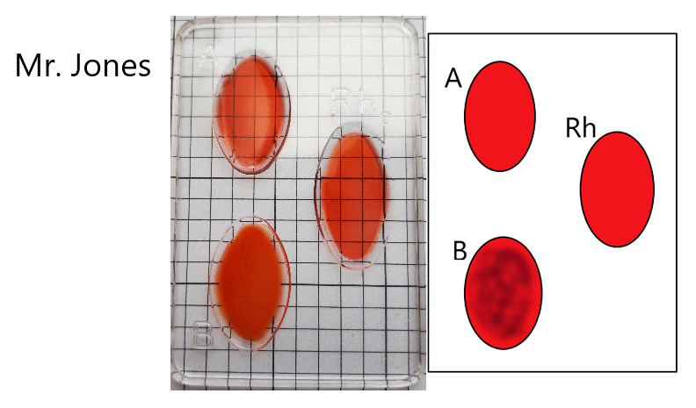

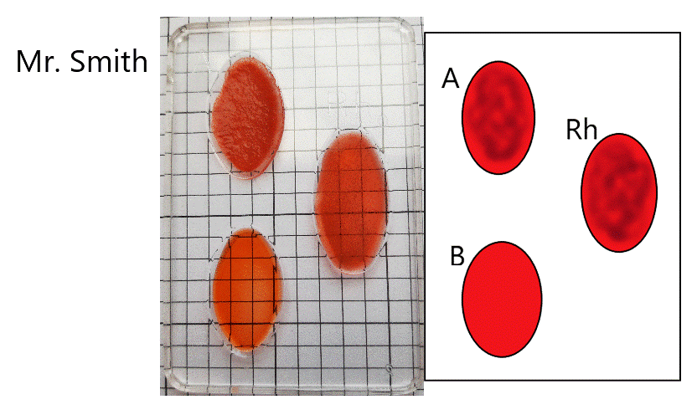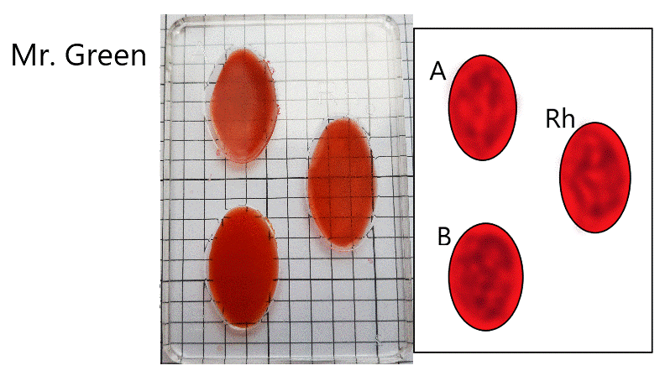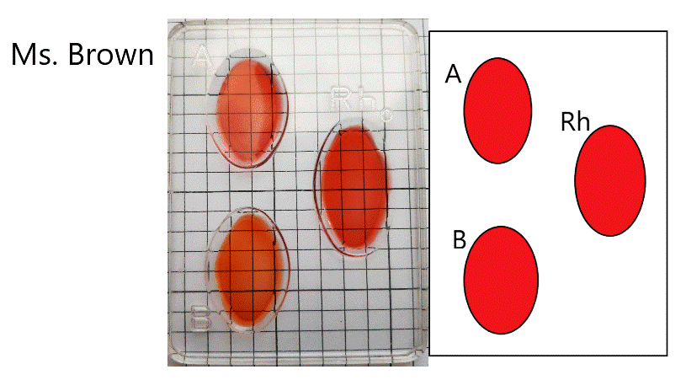

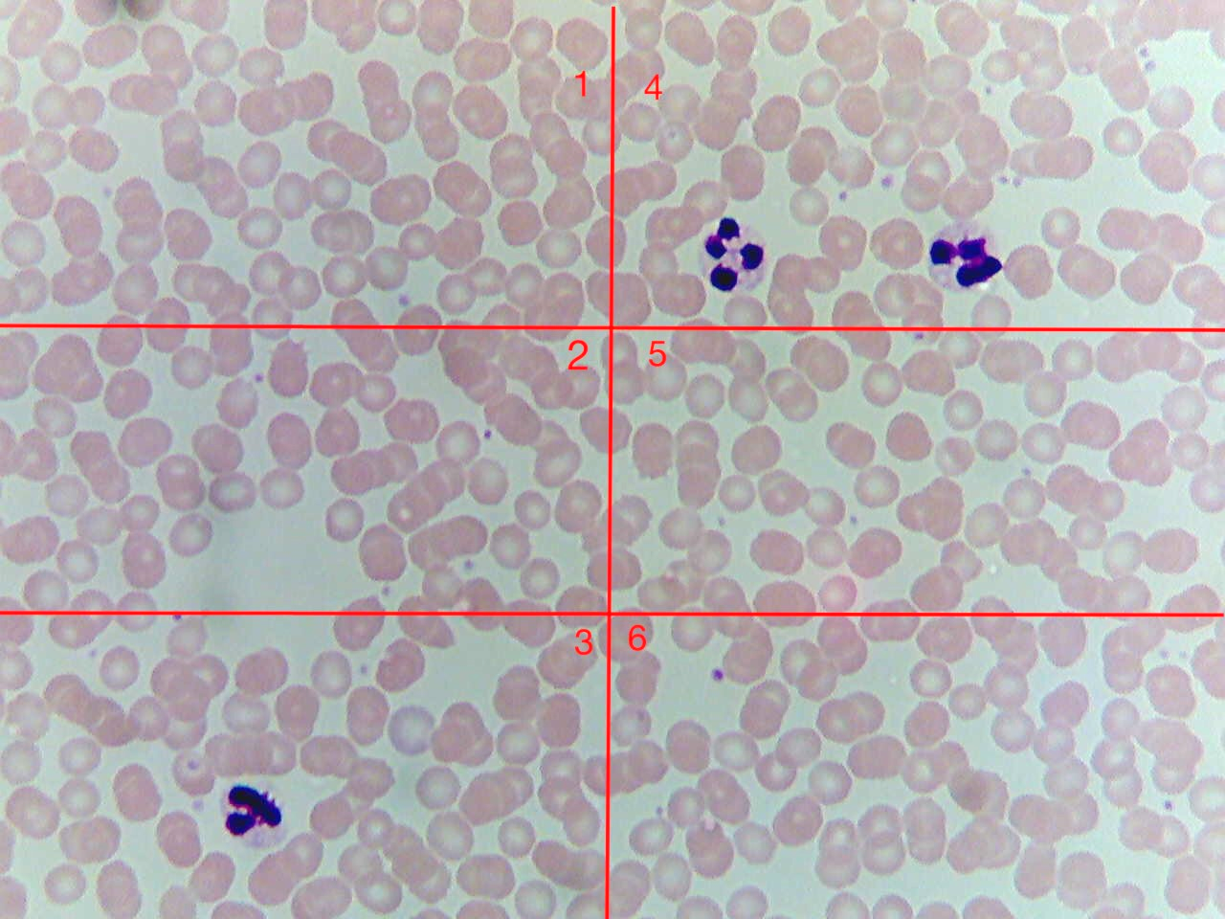
Use the image below to count the number of red and white red blood cells for sections 1, 2, and 3 on the left side of the blood sample. For cells sitting on a line, record it if the majority of the cell is within the box. Some cells may be overlapping. Record the data in Table 4. HINT White blood cells are larger and have purple blotches. (1 pt)

Table 4. Relative Counts of Red and White Blood Cells.
Group Number | Number of Cells
 | Red | White
1
2
3
4 | 103 | 2
5 | 87 | 0
6 | 95 | 0
Total
Ratio of RBC:WBC = | (insert ratio number here):1

- Mr. Jones receives a blood transfusion from Mr. Smith. What do you expect will happen, and why? Explain, using vocabulary from the introduction. (4 pts)

- If Mr. Green needed a blood transfusion, who should he ask? Please list all acceptable donors, and explain why Mr. Green would be able to tolerate their blood types. (Include all relevant antigens in your explanation.) (3 pts).

- Ms. Brown is pregnant, and tests reveal her baby has type B+ blood. Will she need to be given antiserum during labor? Does this protect her current first child, or future babies? Explain why or why not using concepts and vocabulary from the introduction. (3pts)

- Ms. Purple is wheeled into the emergency room with a high fever. A technician collects a blood sample, and later reports that Ms. Purple has red blood cell and white blood cell counts as listed in Table 4. Do you think Ms. Purple has an infection? Explain why, using both the information given here, and information from the lab introduction. (3 pts)

- Tuberculosis is a chronic respiratory condition caused by Mycobacterium tuberculosis, a high contagious bacterium. People with tuberculosis will often have a persistent (sometimes bloody) cough, fatigue, weight loss, and fever. M. tuberculosis produces a protein we will call “X”. A new test for tuberculosis checks for X antibodies in a person’s blood. If the antibodies are present, the result is “positive.” Why would X antibodies be present in someone’s blood? What specific kind of cells would produce them? (2 pts)

- Why are there so many more erythrocytes than leukocytes in both healthy and sick individuals? (2 pts)

