Catalase Lab

Introduction
Catalase is an enzyme found in potatoes that catalyzes a reaction that changes peroxide into oxygen and water.

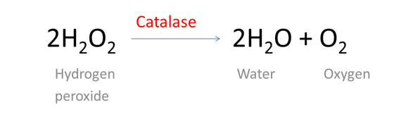

We will be doing this reaction using peroxide and a potato puree and timing how long the oxygen produced takes to float submerged discs of paper in our test tube.

Procedure
Part 1
1) Label your test tubes #1 and #2. Put 10 ml of room temperature peroxide into each.

2) Place about 5 paper discs into each tube and swirl to make sure they sink to the bottom.

3) Add a half dropper (about 1.5 ml) of catalase to tube #1 and swirl. Time how long it takes ALL discs to float. When all discs have floated, measure the height of the bubble layer in mm. RECORD DATA ON TABLE.

4) Add a half dropper (about 1.5 ml) of BOILED CATALASE into tube #2 and swirl. Time how long it takes ALL discs to float. When all discs have floated, measure the height of the bubble layer in mm.
RECORD DATA ON TABLE

Part 2
1) Rinse both test tubes well and be sure the water has been shaken out.
2) Repeat all steps from Part 1 using cold peroxide from the refrigerator.

Results
 | Time for Discs to Float (seconds) | Height of bubble layer (mm)
Test Tube 1
(Room temperature Peroxide and catalase)
Test Tube 2
(Room temperature Peroxide and BOILED CATALASE)
Test Tube 3
(Cold Peroxide and catalase)
Test Tube 4
(Cold Peroxide and BOILED CATALASE)

Conclusion

1) In which tube did you see the strongest reaction? Why do you think that is?

2) What happened when the catalase was boiled?

