Evolution Notes Part 2: Evidence for Evolution

Formation of New Species

1) Natural Selection causes the ________________________ of _______________ to change in the population.

2) _______________________- populations of the same species that differ genetically because of adaptations to different living conditions

3) Reproductive isolation-

Example:

4) ________________________- process by which new species form

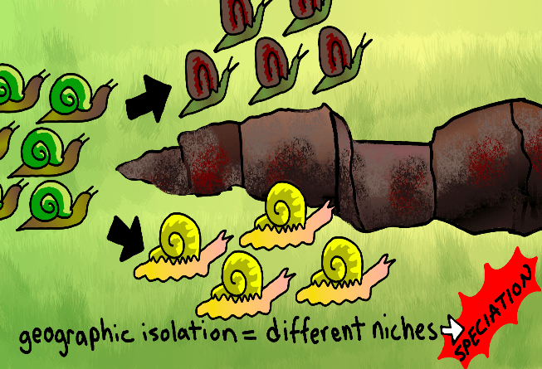

5) Gradualism-

6) Punctuated equilibrium-

Evidence for Evolution

7) transitional fossils-

8) homologous structure-

9) analogous structure-

10) Which one comes from a common ancestor, a homologous structure or an analogous structure?

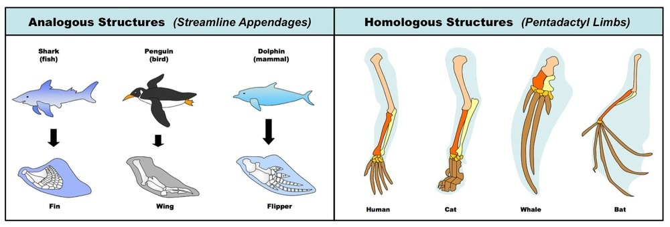

11) vestigial structure-

Biological Molecules
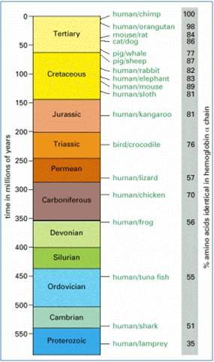
12) What molecule is commonly used to determine evolutionary relationships?

13) What does similarity in protein structures show in terms of evolution? (Close relationship or distant relationship?)

