Gene Regulation Notes
1) What is gene regulation?
2) All cells have the exact same ____________.
3) How is the type of a cell determined?
4) promoter-

Prokaryotic Gene Regulation
5) Operon-
6) lac operon-
7) operator-
8) repressor-

9) Describe the operon when lactose is NOT present:

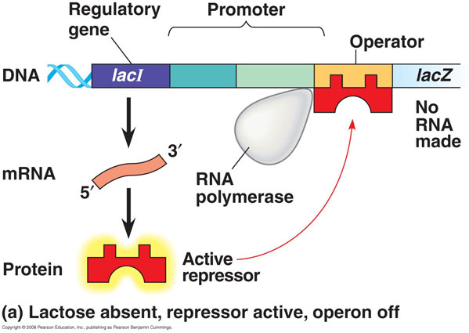

10) Describe the operon when lactose is present:

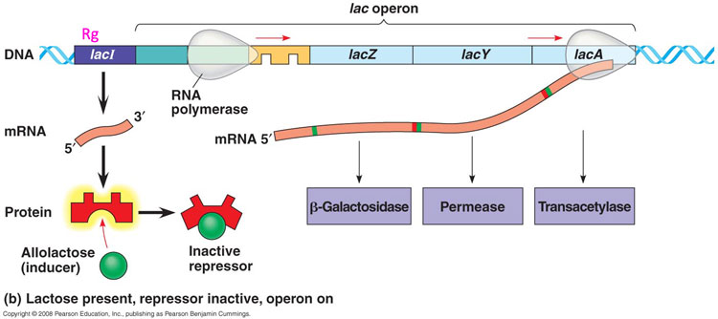

Eukaryotic Gene Regulation
11) Eukaryotic genes are controlled _______________________________.
Do eukaryotic genes have operons?

12) Transcription factor-
13)Differentiation-
14) Which genes control differentiation in the embryo?

