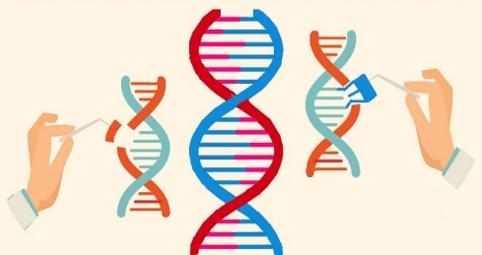
Genetic Engineering Guided Notes

1) Genetic engineering-

2) Recombinant DNA-

3) Transgenic organism-

4) What do we insert into an embryo to make a transgenic organism?

Genetic Engineering Tools

5) vector (plasmid)-

6) restriction enzyme-

4 Steps to get gene of interest into new organism:

1)

- _____________ and _________________ process

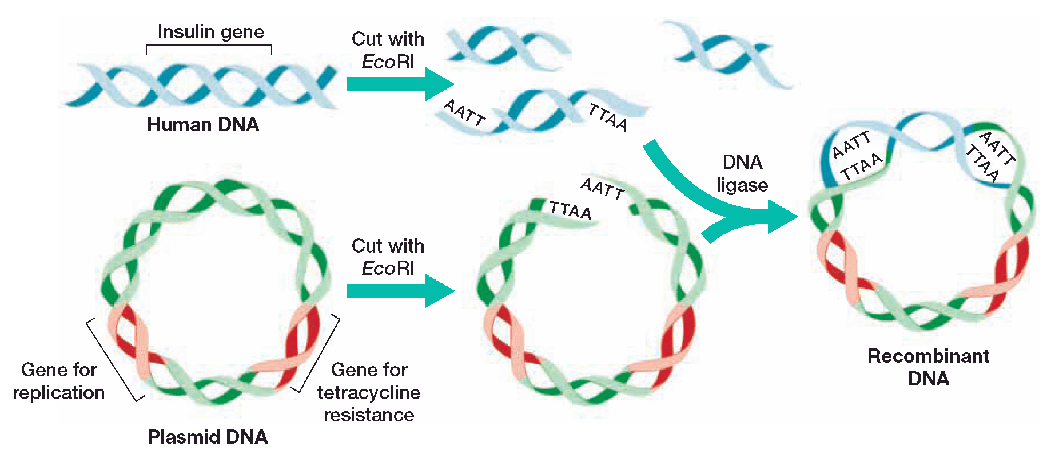
In the example above the ____________________ gene is taken from _____________ (what species) DNA and put into a __________________.

2)

3)

Putting a gene into bacteria
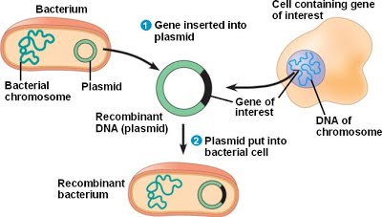

Putting a gene into a plant

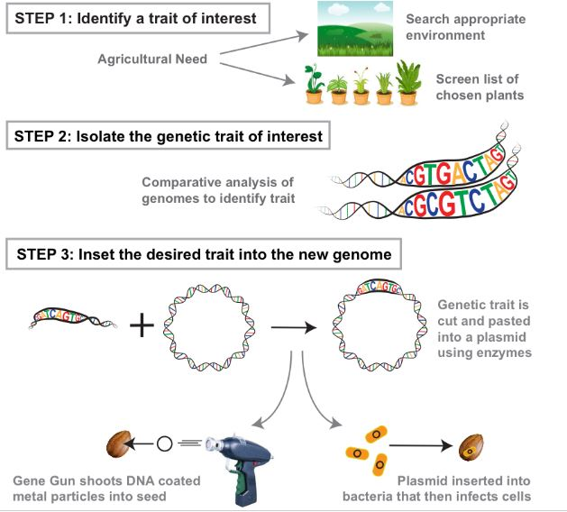
Some Processes that are used in Genetic Engineering

1) Electrophoresis-

- DNA is __________________________ so it moves towards the positive end

- Which will travel farther- smaller or larger pieces of DNA?

2) Polymerase Chain Reaction-

- Uses an enzyme that comes from bacteria that lives in _________________ _________________.

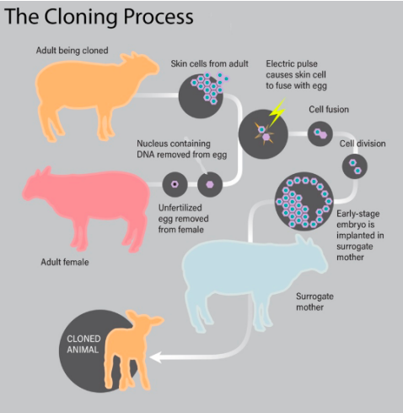

3) Whole organism cloning
How is it done?

4) DNA Fingerprinting-

- How is it made?

-Give an example of 2 individuals that would have the same DNA fingerprint:

