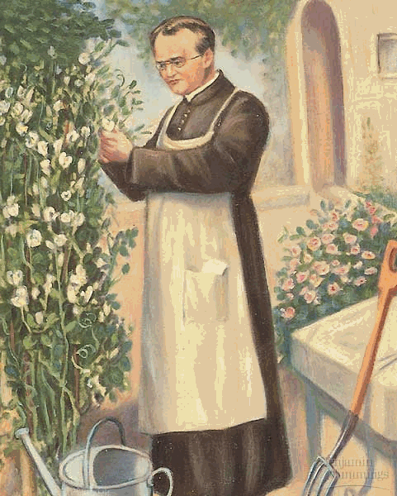
Genetics Guided Notes Part 1

Heredity-

Genetics-

Meet Gregor Mendel!

Gregor Mendal- “_______________ _________ _________________”

What did he study?

Character-

Example- flower color

Trait-

Example- purple flowers

Peas can self-pollinate, but you can also _________________________________by removing the
male part of the flowers.

True-breeding-

Hybrid-

Mendel’s 7 Characters
1.

2.

3.

4.

5.

6.

7.

Mendel’s first cross

The parents (also known as the ____ generation)

They were _____________-breeding and had ___________________ traits.

Example- He cross- pollinated plants with purple flowers with plants that had white flowers

The offspring of the first cross (also known as the _______ generation)

They only showed the trait of __________ parent.
*** See table below for the traits that were seen in the offspring.

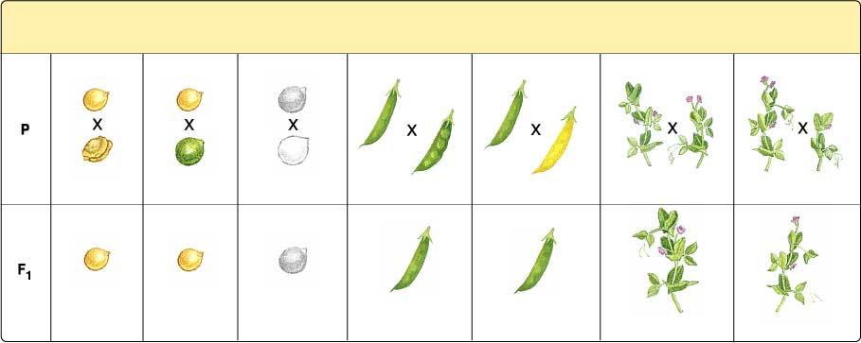

What we Know Today (Principle of Dominance)
Gene-
Allele-

Each organism gets ___________ alleles for a trait, one from its mother and one from its father.

Types of Alleles:
Dominant alleles (_______________case letters)-
Recessive alleles (_______________ case letters)-

Genotype-

Phenotype-
Homozygous-

Heterozygous-

Practice:
In Mendel’s cross between tall plants and short plants, what were the genotypes of the parents?
___________x ____________.
What were the phenotypes of the parents?

Were the F1 generation peas homozygous or heterozygous?

Mendel’s 2nd cross

Parents-

What are the offspring called?

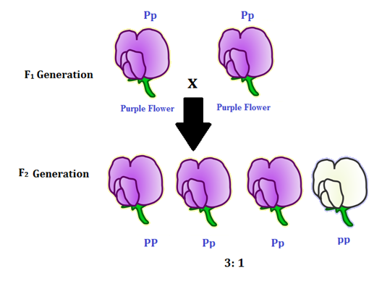
What traits were present in the offspring and at what ratio _____:______?

Mendel’s Crosses Summary

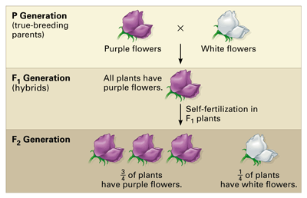

Principal of Segregation

Segregation-

In meiosis when do homologous chromosomes separate?

Review: What are genes?

