Introduction to Biology Notes

Biology is:

Characteristics of Living Things
List and describe the 8 characteristics of living things in the powerpoint:

1)

2)

3)

4)

5)

6)

7)

8)

Benefits of biology:
1)

2)

3)

4)

Write down 2 branches of biology and describe what they study:

1)

2)

HOW IS RESEARCH DONE?
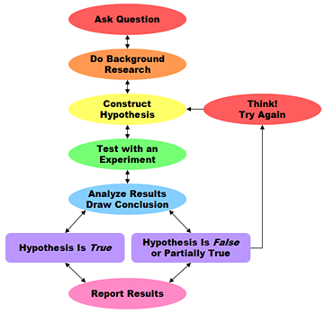
Steps of the scientific method
1) ____________________________________
2) ____________________________________
3) ____________________________________
Definition:
4) ____________________________________
5) ____________________________________
6) ____________________________________
Definition:
7) ____________________________________

Controlled experiment: Only _________ thing is changed at a time!
Example Experiment:

Variable:

Types of variables:
1)

2)

3)

Results
Types of Data
1)

2)

In science, we use the ______________________________system

Types of Graphs:
List and describe the 3 types of graphs:
1)

2)

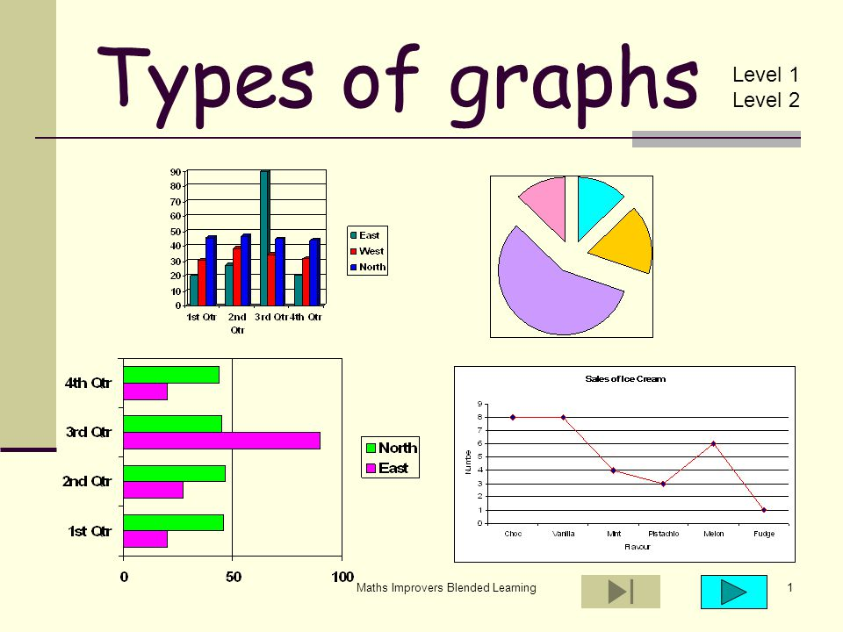
3)

Sample Experiment
Make up your own experiment and label the following:
1) Question:

2) Background research
3) Hypothesis:

4) Controlled Experiment

Independent variable:

Dependent variable:

Controlled variable:

Scientific Theory:

