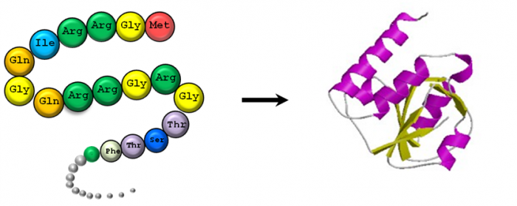
Protein Synthesis Notes

Proteins and Protein Structure
1) Proteins-

2) Elements that make up Proteins:

3) Monomer that makes up proteins (draw basic structure):
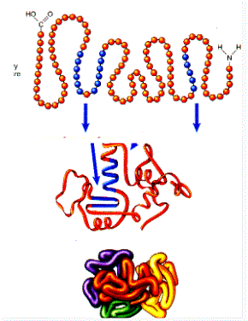

4) How many types of monomers are there?

5) Structure of Proteins:

6) Types and function (list all 5):

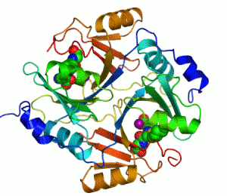
Enzymes
1) Reactants-

2) Products-

3) Catalyst-
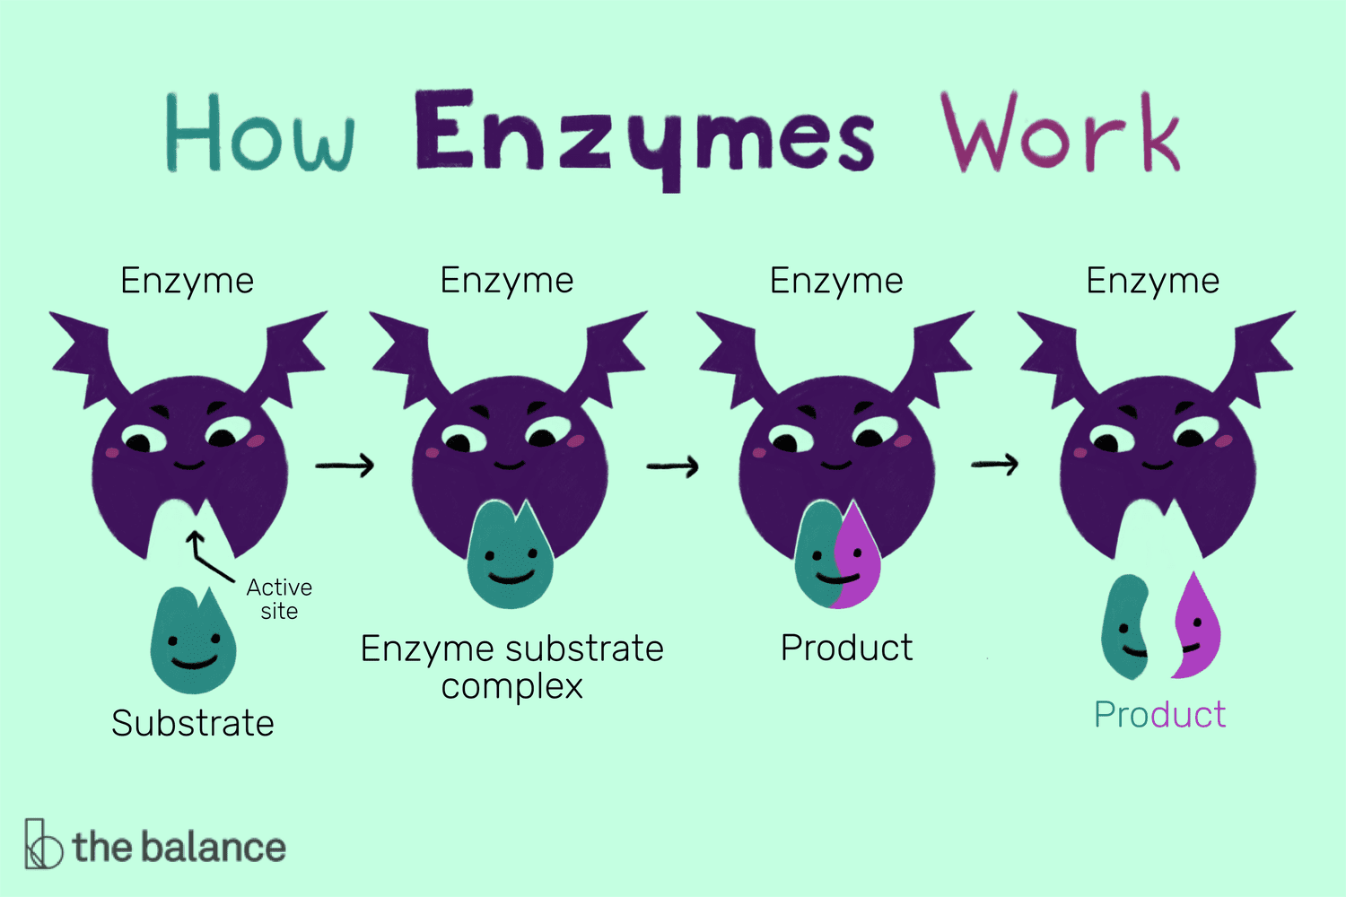
4) Enzyme:

5) MOST ENZYMES ARE ___________________________

6) Substrate-

7) Active Site of Enzyme-

8) Enzymes fit their substrates like a _________________ and _________________
9) Enzyme-substrate complex-

10) Factors that affect enzymes
1)
2)
3)
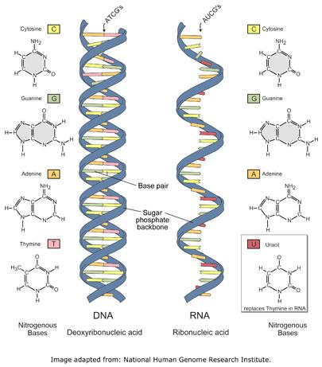
Protein Synthesis
1) protein synthesis-

2) gene-

RNA (Main player in protein synthesis)
1) Ribonucleic Acid (RNA) is a type of ___________________ ___________________.
2) Ways RNA is different from DNA:
1.

2.

3.

3) 4 Bases in RNA
1.
2.
3.
4.

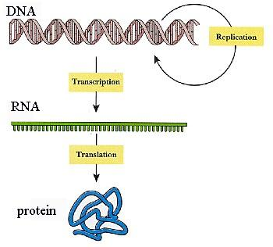
Protein Synthesis Main Parts
Basic Steps in Protein Synthesis
1.
2.

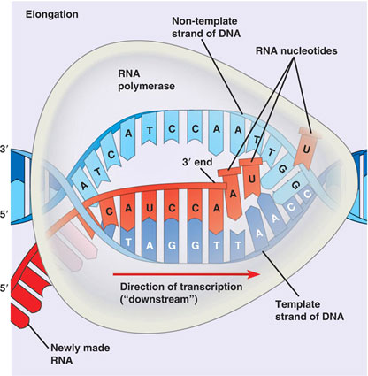
Transcription
1) Location of transcription-
2) Objective of transcription-
3) mRNA-

4) Steps of Transcription
1.
2.
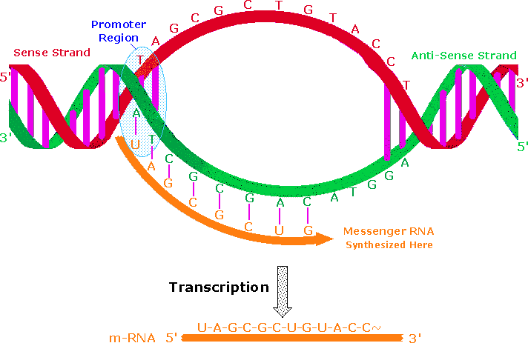
3.
5) Practice Transcription
DNA: ACGGATG
mRNA:

mRNA Editing
1) Introns-
“_____________ _______ _________”
2) Exons-
3) Introns-
4) After editing, where does the mRNA transcript go?

The Code
1) Codon
2) genetic code- the amino acids and “start” and “stop” signals that are coded for by each of the possible 64 mRNA codons (see figure below)
Example: UUU codes for Phenylalanine

3) What does GAG code for?
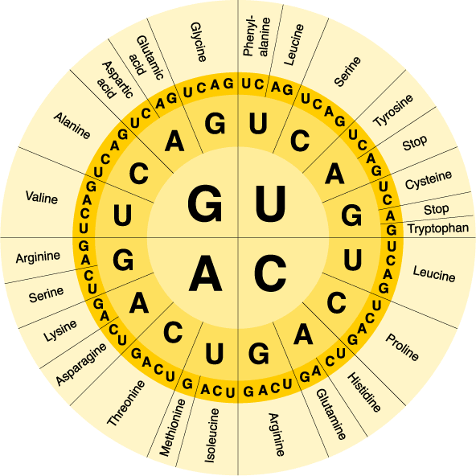

Start at center and go out to decipher code
Make sure you have mRNA first!!

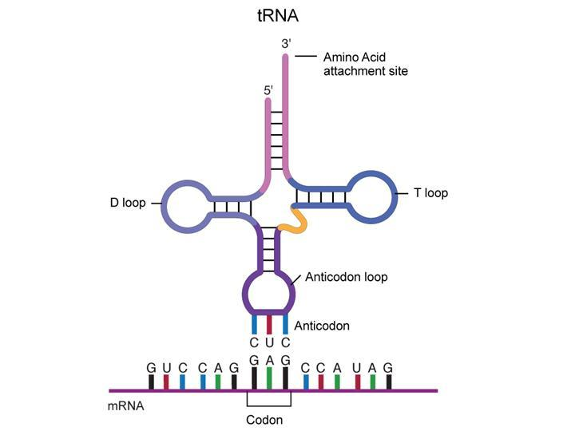
Translation
1) Location of translation-
2) Objective of translation-
3) Important molecules for Translation
1. tRNA-

2. rRNA-
4) Steps of Translation
1.

2.

3.

4.

5.

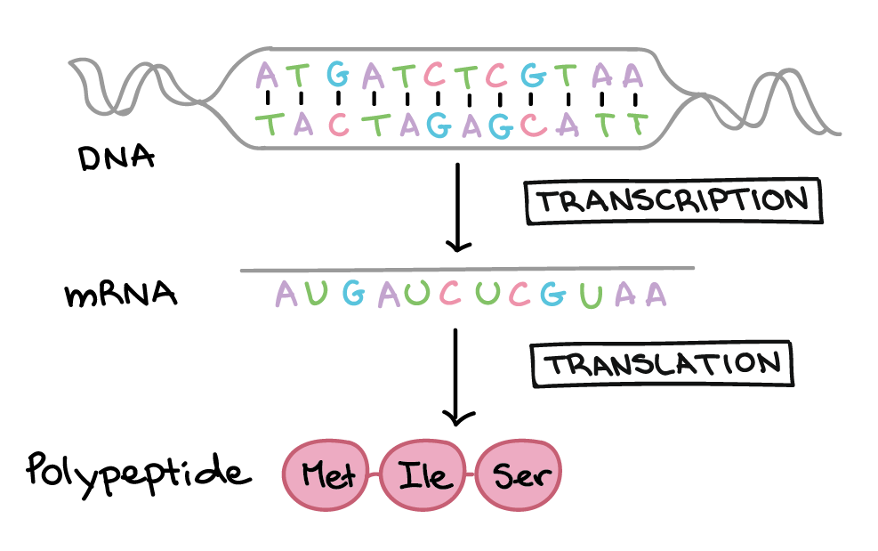
5) The first amino acid in a protein is always ______________.

6) The first codon read on the mRNA is always __________________.

7) Practice:

DNA: TAC GTA CCT AAT TGA ATT
mRNA:
amino acid sequence:

